Chain of Responsibility Design Pattern in Java
Chain of responsibility pattern is used to achieve loose coupling in software design where a request from client is passed to a chain of objects to process them. Then the object in the chain will decide themselves who will be processing the request and whether the request is required to be sent to the next object in the chain or not.
Let’s see the example of chain of responsibility pattern in JDK and then we will proceed to implement a real life example of this pattern. We know that we can have multiple catch blocks in a try-catch block code. Here every catch block is kind of a processor to process that particular exception.
So when any exception occurs in the try block, its send to the first catch block to process. If the catch block is not able to process it, it forwards the request to next object in chain i.e next catch block. If even the last catch block is not able to process it, the exception is thrown outside of the chain to the calling program.

Chain of Responsibility Design Pattern Important Points

- Client doesn’t know which part of the chain will be processing the request and it will send the request to the first object in the chain. For example, in our program ATMDispenseChain is unaware of who is processing the request to dispense the entered amount.
- Each object in the chain will have it’s own implementation to process the request, either full or partial or to send it to the next object in the chain.
- Every object in the chain should have reference to the next object in chain to forward the request to, its achieved by java composition.
- Creating the chain carefully is very important otherwise there might be a case that the request will never be forwarded to a particular processor or there are no objects in the chain who are able to handle the request. In my implementation, I have added the check for the user entered amount to make sure it gets processed fully by all the processors but we might not check it and throw exception if the request reaches the last object and there are no further objects in the chain to forward the request to. This is a design decision.
- Chain of Responsibility design pattern is good to achieve lose coupling but it comes with the trade-off of having a lot of implementation classes and maintenance problems if most of the code is common in all the implementations.

Chain of Responsibility Pattern Examples in JDK
- java.util.logging.Logger#log()
- javax.servlet.Filter#doFilter()

Chain of Responsibility Design Pattern Example
One of the great example of Chain of Responsibility pattern is ATM Dispense machine. The user enters the amount to be dispensed and the machine dispense amount in terms of defined currency bills such as 50$, 20$, 10$ etc.
If the user enters an amount that is not multiples of 10, it throws error. We will use Chain of Responsibility pattern to implement this solution. The chain will process the request in the same order as below image.
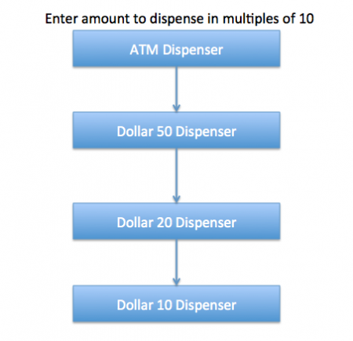
Note that we can implement this solution easily in a single program itself but then the complexity will increase and the solution will be tightly coupled. So we will create a chain of dispense systems to dispense bills of 50$, 20$ and 10$.

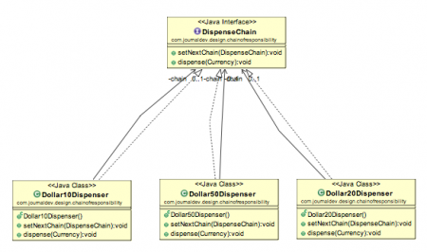
package com.test.design.pattern.chain.of.responsiblity;

public class Currency {

private int amount;

public Currency( int amount ) {
this.amount = amount;
}

public int getAmount() {
return amount;
}

}

package com.test.design.pattern.chain.of.responsiblity;

public interface DispanceChain {

public void setNextChain( DispanceChain chain );

public void dispance( Currency currency );

}

package com.test.design.pattern.chain.of.responsiblity;

public class Ruppies100Dispence implements {

private DispanceChain chain;

@Override
public void setNextChain( DispanceChain chain ) {
this.chain = chain;
}

@Override
public void dispance( Currency cur ) {

if(cur.getAmount() >= 100){
int num = cur.getAmount()/100;
int remainder = cur.getAmount() % 100;
System.out.println("Dispensing "+num+" 100$ note");
if(remainder !=0) this.chain.dispance(new Currency(remainder));
}else{
this.chain.dispance(cur);
}
}

}

package com.test.design.pattern.chain.of.responsiblity;

public class Ruppies10Dispence implements DispanceChain {

private DispanceChain chain;

@Override
public void setNextChain( DispanceChain chain ) {
this.chain = chain;
}

@Override
public void dispance( Currency cur ) {
if( cur.getAmount() >= 10 ) {
int num = cur.getAmount() / 10;
int remainder = cur.getAmount() % 10;
System.out.println( "Dispensing " + num + " 10$ note" );
if( remainder != 0 )
this.chain.dispance( new Currency( remainder ) );
}
else {
this.chain.dispance( cur );
}
}

}

package com.test.design.pattern.chain.of.responsiblity;

public class Ruppies20Dispence implements DispanceChain{

private DispanceChain chain;

@Override
public void setNextChain( DispanceChain chain ) {
this.chain = chain;
}

@Override
public void dispance( Currency cur ) {
if(cur.getAmount() >= 20){
int num = cur.getAmount() / 20;
int remainder = cur.getAmount() % 20;
System.out.println( "Dispensing " + num + " 20$ note" );
if( remainder != 0 )
this.chain.dispance( new Currency( remainder ) );
}else {
this.chain.dispance( cur );
}
}

}

package com.test.design.pattern.chain.of.responsiblity;

public class Ruppies50Dispence implements DispanceChain {

private DispanceChain chain;

@Override
public void setNextChain( DispanceChain chain ) {
this.chain = chain;
}

@Override
public void dispance( Currency cur ) {
if( cur.getAmount() >= 50 ) {
int num = cur.getAmount() / 50;
int remainder = cur.getAmount() % 50;
System.out.println( "Dispensing " + num + " 50$ note" );
if( remainder != 0 )
this.chain.dispance( new Currency( remainder ) );
}
else {
this.chain.dispance( cur );
}
}

}

package com.test.design.pattern.chain.of.responsiblity;

import java.util.Scanner;

public class ATMDispanceChain {

public ATMDispanceChain() {
}

public static void main( String args[] ) {

DispanceChain ruppies100Dispence = new Ruppies100Dispence();
DispanceChain ruppies50Dispence = new Ruppies50Dispence();
DispanceChain ruppies20Dispence = new Ruppies20Dispence();
DispanceChain ruppies10Dispence = new Ruppies10Dispence();

ruppies100Dispence.setNextChain( ruppies50Dispence );
ruppies50Dispence.setNextChain( ruppies20Dispence );
ruppies20Dispence.setNextChain( ruppies10Dispence );

while( true ) {
int amount = 0;
System.out.println( "Enter amount to dispense" );
Scanner input = new Scanner( System.in );
amount = input.nextInt();
if( amount % 10 != 0 ) {
System.out.println( "Amount should be in multiple of 10s." );
return;
}
// process the request
ruppies100Dispence.dispance( new Currency( amount ) );
}

}

}

